*Florida International University*

*School of Computing and Information Science*

Final Deliverable

Project:

**Vocabulary In Reading Study**

Current Team Members: Lucas Stumpf, Isaac Lomax, Oscar Molina, Jose Rodriguez, Adrian Bustos, Gino Surace, Denae Miller, Gentman Tan, Jeffrey Quispe, Denzel Merrell, Evers Perez

Product Owners: Eric Dwyer

Instructor: Masoud Sadjadi

 

The MIT License (MIT)

Copyright (c) 2016 Florida International University

Permission is hereby granted, free of charge, to any person obtaining a copy of this software

and associated documentation files (the "Software"), to deal in the Software without restriction,

including without limitation the rights to use, copy, modify, merge, publish, distribute, sublicense,

and/or sell copies of the Software, and to permit persons to whom the Software is furnished to

do so, subject to the following conditions:

The above copyright notice and this permission notice shall be included in all copies or

substantial portions of the Software.

THE SOFTWARE IS PROVIDED "AS IS", WITHOUT WARRANTY OF ANY KIND, EXPRESS

OR IMPLIED, INCLUDING BUT NOT LIMITED TO THE WARRANTIES OF

MERCHANTABILITY, FITNESS FOR A PARTICULAR PURPOSE AND NONINFRINGEMENT.

IN NO EVENT SHALL THE AUTHORS OR COPYRIGHT HOLDERS BE LIABLE FOR ANY

CLAIM, DAMAGES OR OTHER LIABILITY, WHETHER IN AN ACTION OF CONTRACT, TORT

OR OTHERWISE, ARISING FROM, OUT OF OR IN CONNECTION WITH THE SOFTWARE

OR THE USE OR OTHER DEALINGS IN THE SOFTWARE.

# Abstract

*This document goes over the Vocabulary in Reading Study mission and the software solutions that were implemented. The purpose of Vocabulary in Reading Study is to provide English language learners and educators with a tool that will allow them to break down the difficulty of any given word in a text as well as the text itself. The main focus of our work was in optimizing the user experience of the website, refining the current utilities and creating a simplified environment to search .*

# Introduction

## Current System

This is the ninth iteration of the application. The current system is hosted on AWS (Amazon

Web Servers) on an on-demand EC2 instance. It uses AWS RDS with MySQL for the database,

Spring MVC, and Angular/Typescript. Currently the system can analyze text from either typed text submitted through a form or by uploading a file. The website can support the following file extensions: .docx, .pdf, .png and .jpeg; however, all the extensions for documents are not working probably due to some memory issues on the live website. The site gives the user the option to “enhance text” which shows the difficulty of the words found in the text and displays dictionary definitions of the words once you click on them. There is also the statistics feature that gives an in-depth analysis of the text. There is a translator that translates text to many languages. Users can also create profiles as well as test their vocabulary with tests to assess their progression in learning English. There are administrative tools for the product owners to add and remove words from the dictionary/essential words list. The application now has an updated word list that allows to search for every word in the database.

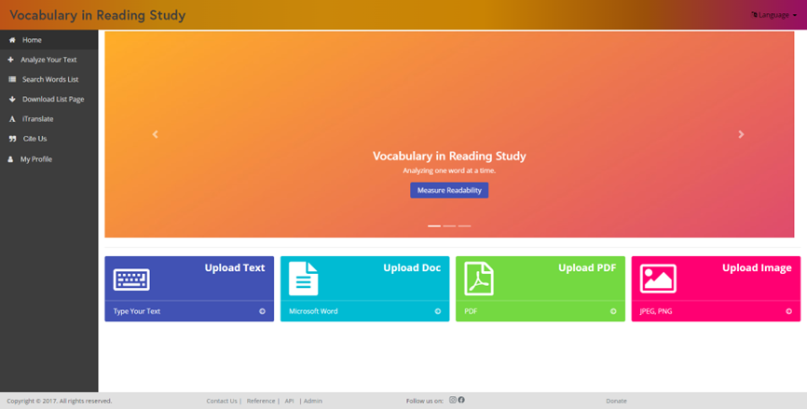

## Purpose of the New System

This semester (VIRS version 9.0), we made a single tab in which the user is able to search for any word. We created filters that can filter through the selected categories. We created a priority order for the word categories in the text analysis component which prioritizes the colored highlighting of certain categories. We also added category descriptions to the text analysis as well as on the filtering options on the search tab. We fixed the following bugs.

* Added K3 to the text statistics.
* Fixed an issue in which the search tabs’ pages weren’t switching properly.
* Fixed formatting on statistics.
* Fixed searching undefined when there is not text in search text area.

Overall the user will have an easier time navigating the VIRS website with the changes we made.

# 

# User Stories

## Implemented User Stories

**User Story [#1]** - Run Coding Environment (10 points)

**Title:** As a software developer, I would like to run the project environment on my personal computer in order to make the necessary changes and improvements to the website.

**Acceptance Criteria:**

Acceptance Criteria 1: Developer can view the front-end on localhost:4200

Acceptance Criteria 2: Developer can successfully build the backend user virs.cmd with no errors

Acceptance Criteria 3: Developer can view the entire application on localhost:8080

Acceptance Criteria 4: Developer can make edits and have the application reflect those changes on localhost:8080

**Estimate:** 5* 4 = 20 points

**User Story [#2]** - Single search page

**Title:** As a user I want to be able to search for any word from a single page on the site

**Acceptance Criteria:**

Acceptance Criteria 1: The site has only one page for searching

Acceptance Criteria 2: Search returns all words that begin with a specified query

Ex: Searching “ba” returns all words that begin with “ba”

Acceptance Criteria 3: Search can be filtered by category in addition to search query

Acceptance Criteria 2: Additional filter options work as expected

* Sort (Asc, Desc)
* Page Length (amount of words to return)
  + 20, 60, ALL
  + Next Page, Previous Page

**Estimate**: 5* 4 = 20 points

**User Story [#3]** - Fix category defaulting process

**Title:** As a user I want to see only the most relevant category for a word when browsing the site

**Acceptance Criteria:**

Acceptance Criteria 1: Categories have priority levels

Acceptance Criteria 2: Words are displayed on the page paired with the matching category with the highest priority

**Estimate**: 5* 4 = 20 points

**User Story [#4]** - Category colors

**Title:** As a user I want the colors associated with each category to be clearly identifiable

**Acceptance Criteria:**

Acceptance Criteria 1: Each category has a unique color

**Estimate**: 5* 4 = 20 points

**User Story [#6]** - Category explanations

**Title:** As a user I want to see the explanation of a category when I hover over it anywhere on the site

**Acceptance Criteria:**

Acceptance Criteria 1: When the cursor is hovered over a category anywhere on the site, a box containing its explanation appears

Acceptance Criteria 2: When the cursor leaves the category text, the box disappears

**Estimate**: 5* 4 = 20 points

**User Story [#3]** - Search using enter or return button

**Title:** Asa user I want to be able to search for a word by pressing the enter button or return button, as opposed to clicking the search button with my mouse

**Acceptance Criteria:**

Acceptance Criteria 1: If the user is focused on the search bar and presses enter, focus switches from the search bar to the search button

Acceptance Criteria 2: All words beginning with the users search query are displayed on the page

**Estimate**: 5* 4 = 20 points

## Pending User Stories

**User Story [#8]** - Grade Levels

**Title:** As a user I want to be able to view words in additional categories which represent student grade levels

**Acceptance Criteria:**

Acceptance Criteria 1: User can filter search by grade level in addition to all other filters

**Estimate**: 5* 4 = 20 points

# 

# Project Plan

This section describes the planning that went into the realization of this project. This project

incorporated the agile development techniques and as such required the sprints to be planned.

These sprint plannings are detailed in the section. This section also describes the components,

both software and hardware, chosen for this project.

## Hardware and Software Resources

The following is a list of all hardware and software resources that were used in this project:

Note: This list of hardware and software stayed the same throughout this semester, so this

is the list made by the previous team.

### Hardware

* Computer running Linux, Mac OS or windows.
* For the deployed application make sure you stay within the AWS server constraints
* 64bit Amazon Linux 2017.03 v2.5.5 running Java 8

### Software

The following list is the software used in the application. Note that it is quite extensive and includes all the development layers of the stack.

#### Front end

* Angular 4.3.1
* Ng-Bootstrap 1.0.0
* Ng-Translate 7.0.0
* Chat.js 2.7.1
* Font-Awesome 4.7.0
* Ng2-Charts 1.6.0
* Rxjs 5.1.0
* Jasmine 2.5.45
* Karma 1.7
* Typescript 2.3.3

#### Back end

* Maven 3.5
  + Commons-lang3 3.4
  + HikariCP 1.5.6.RELEASE
  + Jai-imageio-core 1.3.1
  + Jai-imageio-jpeg2000 1.3.0
  + Jasypt-spring-boot-starter 1.16
  + Levigo-jbig2-imageio 2.0
  + Mysql-connector-java 1.5.6.RELEASE
  + Opencsv 3.3
  + Opencv 3.2.0-1
  + Spring-boot-starter-data-jpa 1.5.6.RELEASE
  + Spring-boot-starter-security 1.5.6.RELEASE
  + Spring-boot-starter-test 1.5.6.RELEASE
  + Spring-boot-starter-web 1.5.6.RELEASE
  + Springfox-swagger-ui 2.7.0
  + Springfox-swagger2 2.7.0
  + Sqlite-jdbc 1.5.6.RELEASE
  + Tess4j 3.4.1
  + Thucydides-core 0.9.275
  + Tika-parsers 1.16
* Tesseract 3.05.01
* Leptonica 1.74.4
* Mysql 14.14
* Java 1.8.0
* Spring Developer Suite 3.9

#### iOS

* Xcode 12.1 (or latest version of xcode)
* Swift 5 (Storyboards not SwiftUI)
* Command line tools 9.2

#### Other

* Git 2.14.1
* Bash 3.2.57

# Sprints Plan

## Sprint 1

**Sprint Planning Meeting Minutes:**

Attendees: **Oscar Molina, Isaac Lomax, Jose Rodriguez, Denzel Merrell, Jeffrey Quispe, Lucas Stumpf, Adrian Bustos, Denae Miller, Christopher Perez, Evers Perez, Gino Surace, Gentman Tan**

Start time: 6:00 P.M.

End time: 7:00 P.M.

After discussion, the velocity of the team was estimated to be 15.

The product owner chose the following user stories to be done during the next sprint. They are ordered based on their priority.

* User Story 1:
  + Adding Labels to words
  + Difficulty: medium-hard
  + Hours: 7
* User Story 2:
  + Change word defaulting process
  + Difficulty: N/A
  + Hours: N/A
* User Story 3:
  + Enter begins search
  + Difficulty: low-medium
  + Hours: 2
* User Story 4:
  + Adding on hover text box for a summary of a label (kind of like an text editor does)
  + Difficulty: medium
  + Hours: 5
* User Story 5:
  + Change the colors of frequency categories
  + Difficulty: low
  + Hours: 2
* User Story 6:
  + Grade analysis based on 13 grades
  + Difficulty: N/A
  + Hours: N/A

The team members indicated their willingness to work on the following user stories.

* User Story 1 (1):
  + TBA
* User Story 2 (3):
  + TBA
* User Story 3 (1):
  + TBA
* User Story 4 (4):
  + TBA
* User Story 5 (3):
  + TBA
* User Story 6 (3):
  + TBA

## Sprint 2

**Sprint Planning Meeting Minutes:**

Attendees: **Oscar Molina, Isaac Lomax, Jose Rodriguez, Denzel Merrell, Jeffrey Quispe, Lucas Stumpf, Adrian Bustos, Denae Miller, Christopher Perez, Evers Perez, Gino Surace, Gentman Tan**

Start time: 6:00 P.M.

End time: 7:00 P.M.

After discussion, the velocity of the team was estimated to be 15.

The product owner chose the following user stories to be done during the next sprint. They are ordered based on their priority.

* User Story 1:
  + Adding Labels to words
  + Difficulty: medium-hard
  + Hours: 7
* User Story 2:
  + Change word defaulting process
  + Difficulty: N/A
  + Hours: N/A
* User Story 3:
  + Enter begins search
  + Difficulty: low-medium
  + Hours: 2
* User Story 4:
  + Adding on hover text box for a summary of a label (kind of like an text editor does)
  + Difficulty: medium
  + Hours: 5
* User Story 5:
  + Change the colors of frequency categories
  + Difficulty: low
  + Hours: 2
* User Story 6:
  + Grade analysis based on 13 grades
  + Difficulty: N/A
  + Hours: N/A

The team members indicated their willingness to work on the following user stories.

* User Story 1 (1):
  + TBA
* User Story 2 (3):
  + TBA
* User Story 3 (1):
  + TBA
* User Story 4 (4):
  + TBA
* User Story 5 (3):
  + TBA
* User Story 6 (3):
  + TBA

## Sprint 3

**Sprint Planning Meeting Minutes:**

Attendees: **Oscar Molina, Isaac Lomax, Jose Rodriguez, Denzel Merrell, Jeffrey Quispe, Lucas Stumpf, Adrian Bustos, Denae Miller, Christopher Perez, Evers Perez, Gino Surace, Gentman Tan**

Start time: 6:00 P.M.

End time: 7:00 P.M.

After discussion, the velocity of the team was estimated to be 15.

The product owner chose the following user stories to be done during the next sprint. They are ordered based on their priority.

* User Story 1:
  + Adding Labels to words
  + Difficulty: medium-hard
  + Hours: 7

Acceptance Criteria:

-VIRS website displays the labels that match the category of the word

-Labels display properly and don’t cause other html elements to be moved unexpectedly.

* User Story 2:
  + Change word defaulting process
  + Difficulty: N/A
  + Hours: N/A

Acceptance Criteria:

N/A

* User Story 3:
  + Enter begins search
  + Difficulty: low-medium
  + Hours: 2

Acceptance Criteria:

-User can press enter to begin search if he chooses to do so.

-Search component still works as intended.

* User Story 4:
  + Adding on hover text box for a summary of a label (kind of like an text editor does)
  + Difficulty: medium
  + Hours: 5

Acceptance Criteria:

-Text box displays properly

-Text box has the correct match of category summary

-Text box is correctly positioned

* User Story 5:
  + Change the colors of frequency categories
  + Difficulty: low
  + Hours: 2

Acceptance Criteria:

-Selected colors represent those that were proposed by the product owner.

-Selected text color is readable over the color selected by the product owner(contrast)

* User Story 6:
  + Grade analysis based on 13 grades
  + Difficulty: N/A
  + Hours: N/A

Acceptance Criteria:

-Words are categorized more specifically

-Words are near their actual grade category

The team members indicated their willingness to work on the following user stories.

* User Story 1 (1):
  + Denzel Merrell (Senior Project)
  + Adrian Bustos (Cap I)
  + Jose Rodriguez (Cap II)
* User Story 2 (3):
  + Christopher Perez (Cap I)
  + Lucas Stumpf (Cap II)
  + Isaac Lomax (Cap ll)
  + Gino Surace (Cap I)
* User Story 3 (1):
  + Lucas Stumpf (Cap II)
  + Jeffrey Quispe (Cap II)
  + Christopher Perez (Cap I)
  + Gentman Tan (Cap I)
* User Story 4 (4):
  + Oscar Molina (Cap II)
  + Adrian Bustos (Cap I)
  + Denae Miller (Cap I)
  + Evers Perez (Cap l)
* User Story 5 (3):
  + Oscar Molina (Cap II)
  + Denae Miller (Cap I)
  + Christopher Perez (Cap I)
* User Story 6 (3):
  + TBA

## Sprint 4

**Sprint Planning Meeting Minutes:**

Attendees: **Oscar Molina, Isaac Lomax, Jose Rodriguez, Denzel Merrell, Jeffrey Quispe, Lucas Stumpf, Adrian Bustos, Denae Miller, Christopher Perez, Evers Perez, Gino Surace, Gentman Tan**

Start time: 6:00 P.M.

End time: 7:00 P.M.

After discussion, the velocity of the team was estimated to be 15.

The product owner chose the following user stories to be done during the next sprint. They are ordered based on their priority.

* User Story 1:
  + Add an explanation of the categories when analyzing text.
  + Difficulty: medium-hard
  + Hours: 3

Acceptance Criteria:

- You can click on the term and a box with its explanation should pop up.

* User Story 2:
  + Fix the retrieving implementation for words and fix the categorization of words.
  + Difficulty: N/A
  + Hours: N/A

Acceptance Criteria:

* Words should be retrievable from one GET route regardless of category
* Academic/STEM takes priority over other categories
* User Story 3:
  + Change the colors of frequency categories
  + Difficulty: low
  + Hours: 2

Acceptance Criteria:

-Selected colors represent those that were proposed by the product owner.

-Selected text color is readable over the color selected by the product owner(contrast)

* User Story 4:
  + Change the UI of the words list tab to our design. Creating one search bar for all categories.
  + Difficulty: medium
  + Hours: 2

Acceptance Criteria:

- Most of the current functionality is preserved.

- Relocated buttons function properly.

The team members indicated their willingness to work on the following user stories.

* User Story 1 (1):
  + Oscar Molina (Cap II)
  + Jeffrey Quispe (Cap II)
* User Story 2 (3):
  + Isaac Lomax (Cap ll)
  + Denzel Merrell (Senior Project)
  + Jose Rodriguez (Cap II)
  + Oscar Molina (Cap II)
* User Story 3 (3):
  + Oscar Molina (Cap II)
  + Jose Rodriguez (Cap II)
* User Story 4 (3):
  + Denzel Merrell (Senior Project)
  + Oscar Molina (Cap II)
  + Denae Miller (Cap I)

## Sprint 5

**Sprint Planning Meeting Minutes:**

Attendees: **Oscar Molina, Isaac Lomax, Jose Rodriguez, Denzel Merrell, Jeffrey Quispe, Lucas Stumpf, Adrian Bustos, Denae Miller, Christopher Perez, Evers Perez, Gino Surace, Gentman Tan**

Start time: 6:00 P.M.

End time: 7:00 P.M.

After discussion, the velocity of the team was estimated to be 15.

The product owner chose the following user stories to be done during the next sprint. They are ordered based on their priority.

* User Story 4:
  + Change the UI of the words list tab to our design. Creating one search bar for all categories.
  + Difficulty: medium
  + Hours: 2

Acceptance Criteria:

- Most of the current functionality is preserved.

- Relocated buttons function properly.

* User Story 5:
  + Change the UI of the website to a better design.
  + Difficulty: medium
  + Hours: 2

Acceptance Criteria:

- Most of the current functionality is preserved.

- Relocated buttons function properly.

-Design is accepted by the product owner.

* User Story 6:
  + Fix filters of search words list tab.
  + Difficulty: medium
  + Hours: 2

Acceptance Criteria:

- Category Filter update its label with the current category.

-Category Filter allows to click other categories when one is already clicked (Still only one category can be active at a time).

* User Story 7:
  + Add a download lists component.
  + Difficulty: easy
  + Hours: 2

Acceptance Criteria:

- Clicking on the component will direct you to a page with links to download the words lists.

-Clicking on a link will start downloading the specified word list.

* User Story 8:
  + Add Cite us component.
  + Difficulty: easy
  + Hours: 2

Acceptance Criteria:

-Clicking on the component directs you to a page with the citation information of the website.

The team members indicated their willingness to work on the following user stories.

* User Story 4 (5):
  + Oscar Molina (Cap II)
  + Jeffrey Quispe (Cap II)
  + Gino Surace (Cap I)
* User Story 5 (3):
  + Isaac Lomax (Cap ll)
  + Denzel Merrell (Senior Project)
  + Jose Rodriguez (Cap II)
  + Oscar Molina (Cap II)
* User Story 6 (4):
  + Oscar Molina (Cap II)
  + Jose Rodriguez (Cap II)
  + Gino Surace (Cap I)
* User Story 7 (2):
  + Denzel Merrell (Senior Project)
  + Oscar Molina (Cap II)
  + Denae Miller (Cap I)
* User Story 8 (2):
  + Denzel Merrell (Senior Project)
  + Oscar Molina (Cap II)
  + Denae Miller (Cap I)

## Sprint 6

**Sprint Planning Meeting Minutes:**

Attendees: **Oscar Molina, Isaac Lomax, Jose Rodriguez, Denzel Merrell, Jeffrey Quispe, Lucas Stumpf, Adrian Bustos, Denae Miller, Christopher Perez, Evers Perez, Gino Surace, Gentman Tan**

Start time: 6:00 P.M.

End time: 7:00 P.M.

After discussion, the velocity of the team was estimated to be 20.

The product owner chose the following user stories to be done during the next sprint. They are ordered based on their priority.

* User Story 5:
  + Change the UI of the website to a better design.
  + Difficulty: medium
  + Hours: 2

Acceptance Criteria:

- Most of the current functionality is preserved.

- Relocated buttons function properly.

-Design is accepted by the product owner.

* User Story 9:
  + Fix percentages of the statistics in all components.
  + Difficulty: medium
  + Hours: 5

Acceptance Criteria:

- All percentages in the statistics for all components will be formatted correctly and represent accurate information.

* User Story 10:
  + Add Grades to words.
  + Difficulty: hard
  + Hours: 15+

Acceptance Criteria:

- Components of the website will work with words that now have a Grade attached to them as well.

The team members indicated their willingness to work on the following user stories.

* User Story 5 (3):
  + Isaac Lomax (Cap ll)
  + Denzel Merrell (Senior Project)
  + Jose Rodriguez (Cap II)
  + Oscar Molina (Cap II)
* User Story 9 (5):
  + Denzel Merrell (Senior Project)
  + Oscar Molina (Cap II)
  + Denae Miller (Cap I)
  + Gino Surace (Cap I)
* User Story 10 (8):
  + Denzel Merrell (Senior Project)
  + Oscar Molina (Cap II)
  + Jeffrey Quispe (Cap II)
  + Denae Miller (Cap I)
  + Gino Surace (Cap I)
  + Gentman Tan (Cap I)

## 

## 

## Sprint 7

**Sprint Planning Meeting Minutes:**

Attendees: **Oscar Molina, Isaac Lomax, Jose Rodriguez, Denzel Merrell, Jeffrey Quispe, Lucas Stumpf, Adrian Bustos, Denae Miller, Christopher Perez, Evers Perez, Gino Surace, Gentman Tan**

Start time: 6:00 P.M.

End time: 7:00 P.M.

After discussion, the velocity of the team was estimated to be 20.

The product owner chose the following user stories to be done during the next sprint. They are ordered based on their priority.

* User Story 5:
  + Change the UI of the website to a better design.
  + Difficulty: medium
  + Hours: 2

Acceptance Criteria:

- Most of the current functionality is preserved.

- Relocated buttons function properly.

-Design is accepted by the product owner.

* User Story 9:
  + Fix percentages of the statistics in all components.
  + Difficulty: medium
  + Hours: 5

Acceptance Criteria:

- All percentages in the statistics for all components will be formatted correctly and represent accurate information.

* User Story 10:
  + Add Grades to words.
  + Difficulty: hard
  + Hours: 15+

Acceptance Criteria:

- Components of the website will work with words that now have a Grade attached to them as well.

* User Story 11:
  + Add final touches to website for demo
  + Difficulty: Easy
  + Hours: 3+

Acceptance Criteria:

- Must make minimal improvements to already developed functionality

* User Story 12:
  + Prepare for Demo Day
  + Difficulty: medium
  + Hours: 5+

Acceptance Criteria:

- Each team member must work on and finish their assigned deliverables and Poster.

- Each member has to work on their part of their presentation both oral and powerpoint.

The team members indicated their willingness to work on the following user stories.

* User Story 5 (3):
  + Isaac Lomax (Cap ll)
  + Denzel Merrell (Senior Project)
  + Jose Rodriguez (Cap II)
  + Oscar Molina (Cap II)
  + Adrian Bustos (Cap I)
* User Story 9 (5):
  + Denzel Merrell (Senior Project)
  + Oscar Molina (Cap II)
  + Denae Miller (Cap I)
  + Gino Surace (Cap I)
  + Adrian Bustos (Cap I)
* User Story 10 (8):
  + Denzel Merrell (Senior Project)
  + Oscar Molina (Cap II)
  + Jeffrey Quispe (Cap II)
  + Denae Miller (Cap I)
  + Gino Surace (Cap I)
* User Story 11 (2):
  + Denzel Merrell (Senior Project)
  + Oscar Molina (Cap II)
  + Jeffrey Quispe (Cap II)
  + Denae Miller (Cap I)
  + Gino Surace (Cap I)
* User Story 12
  + Cap 1, Cap 2 and Senior Project Students.

# System Design

This section contains information on the design decisions that went into this project. The

architecture patterns are outlined and explained. The entire system is shown in a package

diagram and the subsystems are explained. Finally, the design patterns used in the project are discussed.

Note: Our System Design Section has not changed this semester, so the following System Design info is the same as previous semesters’.

## Architectural Patterns

Model View Controller is the main design for the architecture. We are separating the main three

parts of the application: user interaction, processing of information and storage. The segregation

of these concerns favors production since each of the developers work in a separate section. This separation of components makes the system easily modifiable in the future. With this design, we ensure that we have multiple views for a controller; the system produces APIs that can be consumed by any other application.

Client-Server is used in the system to deliver the application. A highly available system that can

be consumed from several parties called for this design. It allows the centralization of the code

logic and database. We had to access the application from the web, iOS and Android devices so this was a very good choice.

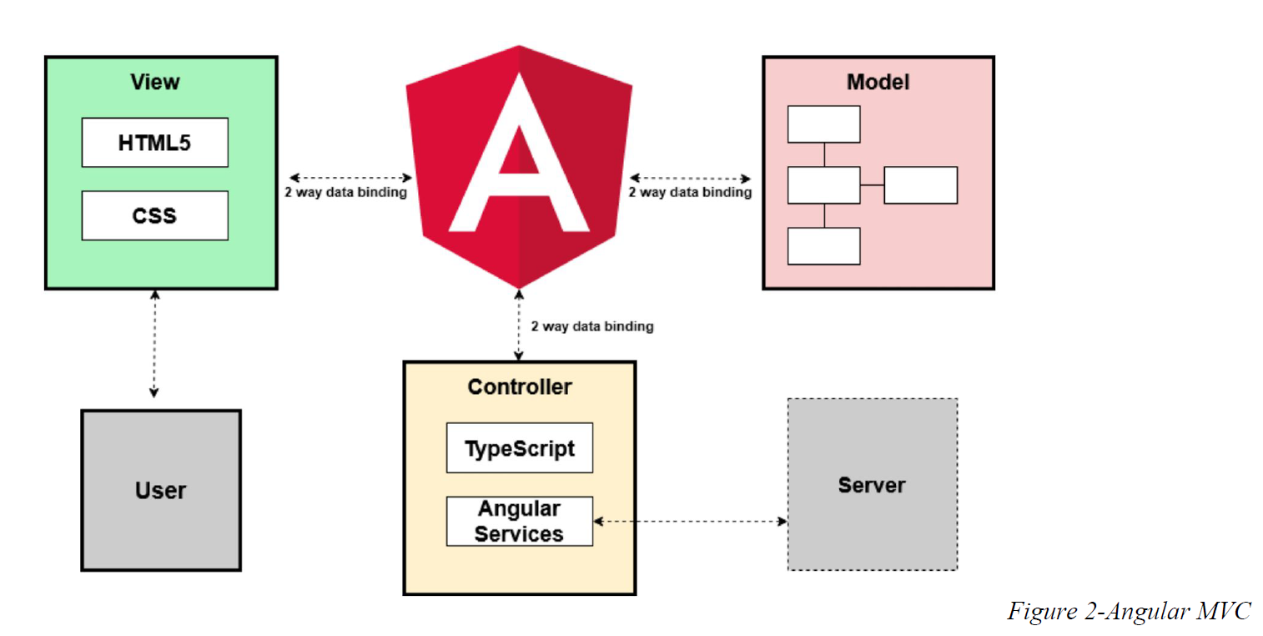

Repository pattern is another design used in our system. It minimizes the amount of duplicate code in the system by abstracting the basic CRUD operations. It also ties the data entities to the domain model which favors development. The code would have to comply with the entity restrictions in order to even comply. It also helps maintain data integrity.

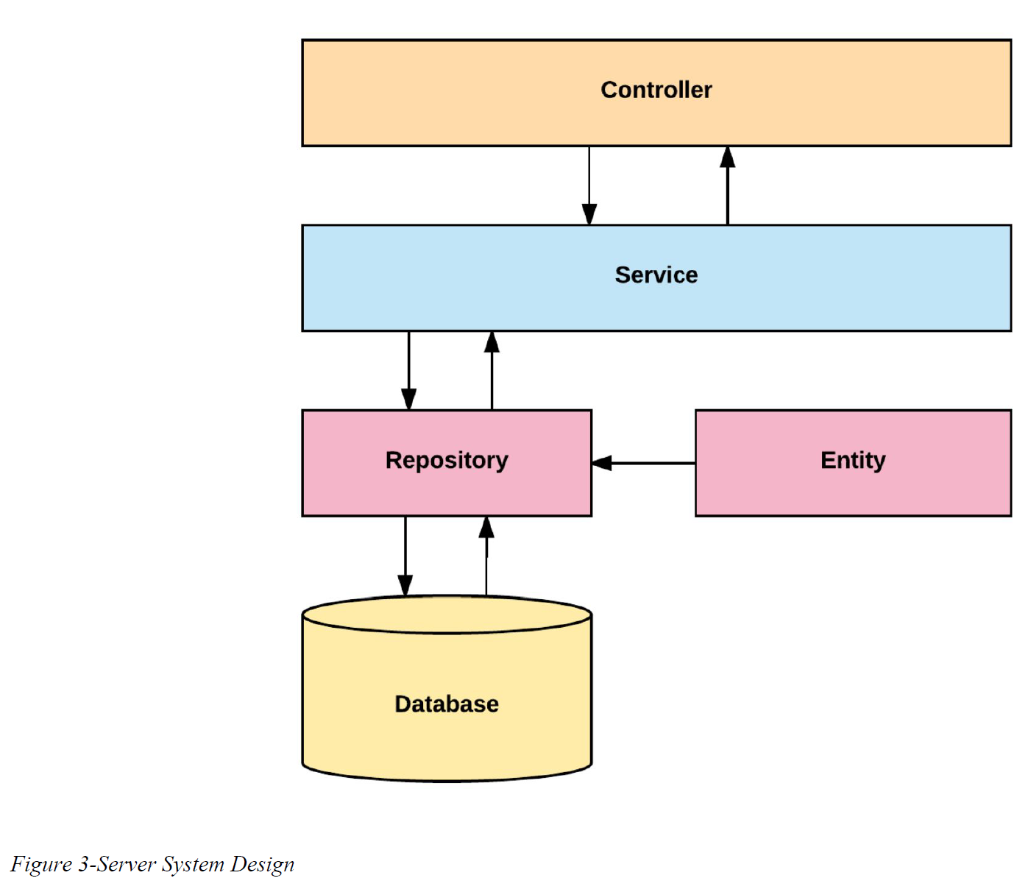

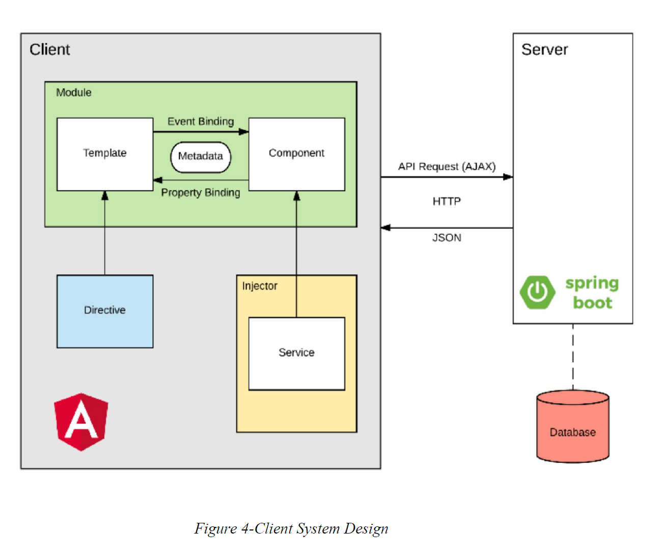

## System and Subsystem Decomposition

The system is made out of two major subsystems and two minor ones. They are broken

down as follows according to its tasks and interactions.

### Server Subsystem

* Interacts with the database.
* Serves all the requests from the web
* Handles server side security.
* Analyzes the statistics of the text.
* Performs OCR.
* Optimizes images.

### Client Subsystem

* Displays the application.
* Routes server-side API calls.
* Contains the main boundaries for user interaction.
* Client side data validation.

### Deployment Diagram

Deployment of the application consists in several steps run with a bash script. It starts in the

front end and it propagates to the backend and eventually to the final product. We are building

with ng for Angular products and Maven for the backend.

This is a detailed explanation for the development pipeline.

* Angular
  + Clean and build the application
  + Run karma tests
  + Run e2e
* Copy resources to the backend
* Spring
  + Increase version number
  + Clean and build
  + Run Unit tests
  + Run Integration tests
  + Create jar executable
* Bundle the application for AWS
* Upload to AWS servers.

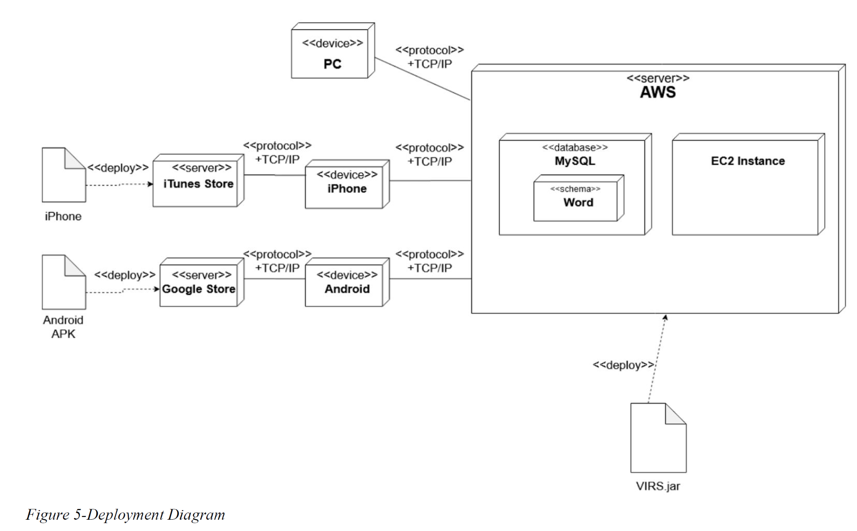

## Design Patterns

The following design patterns were used in the application.

**Dependency Injection:** This is a core design pattern for Spring and Angular 4. It allows the

objects to be readily available and injected when needed rather than having to create them.

**Bridge:** This design pattern is used by the application to interact with libraries that are not

native. Ex: tesseract and OpenCV

**Front controller:** Controllers are one of the main Components in the MVC design.

**Marker:** All components in Spring are annotated with markers to further specify the correct

stereotype. This allows the initialization of the correct optimized components when the

application runs.

**Module:** The application is divided in several modules according to functionality. This

separation promotes organization and grouping of features.

# System Validation

**Test Case ID: TC01_Frontend_Dependencies**

Description: Frontend dependencies should be installed

Test steps:

1. Navigate to virs code/frontend directory

2. Run ‘npm install’ command

Expected result: Frontend installation success message

Actual result: As expected

Status(Pass/Fail): Pass

**Test Case ID: TC02_Backend_dependencies**

Description: Backend dependencies should be installed

Test steps:

1. Navigate to virs code directory

2. Run ‘virs.cmd install-only’ command

Expected result: Backend installation success message

Actual result: As expected

Status(Pass/Fail): Pass

**Test Case ID: TC05_DOCX_FILE_UPLOAD**

Description: Test that the file upload service accepts .docx file uploads with no error.

Test steps:

1. Navigate to the myvirs.com dashboard

2. Select upload document

3. Select a .docx file for upload and hit enhanced text

4. Wait to see the screen change to the enhanced text display

Expected result: .docx file is uploaded with no errors, and the enhanced text screen is shown

Actual result: As expected

Status(Pass/Fail): Pass

**Test Case ID: TC06_DOCX_WORD_OCR**

Description: Docx files that are uploaded have their text displayed correctly on the enhanced text screen

Test steps:

1. Navigate to the myvirs.com dashboard

2. Select upload document

3. Select a .docx file for upload and hit enhanced text

4. View the words; Scroll if necessary to see all the text from the uploaded document.

Expected result: Words from the chosen docx file appear on the screen

Actual result: As expected

Status(Pass/Fail): Pass

**Test Case ID: TC07_PDF_FILE_UPLOAD**

Description: Test that the file upload service accepts .pdf file uploads with no error.

Test steps:

1. Navigate to the myvirs.com dashboard

2. Select upload pdf

3. Select a .pdf file to upload and hit enhanced text

4. Wait to see the screen change the enhanced text display

Expected result: PDF is uploaded with no errors, and the enhanced text screen is shown

Actual result: As expected

Status(Pass/Fail): Pass

**Test Case ID: TC08_PDF_WORD_OCR**

Description: Test that the ENTIRE .pdf file uploads with no error.

Test steps:

1. Navigate to the myvirs.com dashboard

2. Select upload pdf

3. Select a .pdf file to upload and hit enhanced text

4. View the words; Scroll if necessary to see all the text from the uploaded .pdf file.

Expected result: The text from the chosen .pdf are displayed on the enhanced text screen

Actual result: As expected

Status(Pass/Fail): Pass

**Test Case ID: TC10_NEW_AWS_DEPLOYMENT**

Description: Test that we can upload a new version of the code to AWS Elastic beanstalk and have the site updated.

Test steps:

1. Login to AWS Dashboard

2. Navigate to elastic beanstalk

3. Navigate to VocabularyInReading application

4. Navigate to application versions

5. Hit upload, fill out the information and select the file for the updated app

6. Wait for the site to upload and reload the application

7. Ensure that the site is running again and the changes made in the new version are reflected.

Expected result: New version of application is uploaded to AWS and the changes made in the update are visible on the site upon reload.

Actual result: As expected

Status(Pass/Fail): Pass

**Test Case ID: TC_11_Correct_Mobile_View**

Description: Verify that the mobile site no longer contains formatting errors.

Test steps:

1. Open up the website on a mobile device

2. Navigate to each section of the website and check that it looks the same as the desktop site.

3. Navigate to the bottom of the page and verify that no donation button is shown.

Expected result: The site will be correctly displayed on the desktop site and the mobile version of the site.

Actual result: As expected

Status(Pass/Fail): Pass

**Test Case ID: TC_12_Download_List**

Description: Check that the words lists are downloading properly

Test steps:

1. Open up the website

2. Click on the the download list tab

3. Click any of the lists

Expected result: The list should begin to download the selected lists.

Actual result: As expected

Status(Pass/Fail): Pass

**Test Case ID: TC_13_Text_Analysis_Prioirity**

Description: Verify that the words are getting assigned the highest priority

Test steps:

1. Open up the website

2. Click on the text analysis

3. Copy and paste a piece of text

4. Click analyze text

5. Open SQL database, locally search words from the piece of text and look at the categories the word appear in.

6. Look at the category with highest priority for that word and check if it matches the category highlighting in the website.

Expected result: Text analysis component should assign the correct priority.

Actual result: As expected

Status(Pass/Fail): Pass

# Glossary

Note: Glossary didn’t change in VIRS v6.0 from previous versions

**K1:** Among the list of the 1000 most frequently used words in primary and secondary texts.

**K2:** Among the list of the 2nd 1000 most frequently used words in primary and secondary texts.

**K3:** Among the list of the 3rd 1000 most frequently used words in primary and secondary texts.

**Academic Word List (AWL):** List of commonly occurring words among a wide variety of academic subjects but not within the 2000 most frequent words.

**STEM:** List of words occurring in Math or Science texts but not within the 2000 most frequent words.

**High-Frequency List:** List of words that are used more than 100 times per 10 million words but not within the 3000 most commonly used words.

**Medium-Frequency List:** List of moderately occurring words, occurring between 10 to 100 times per 10 million words.

**Low-Frequency List:** List of rarely occurring words, occurring only 1 to 10 times per 10 million words.

**Flesch Reading Ease Score:** A test designed to calculate how hard a text is to understand in

English.

**Word Definition:** Meaning of a word as per Wiki Dictionary. It contains etymology, meaning,

and usage information.

**Category:** The assigned value to a word from one of the above lists. A word category can be:

AWL, High Frequency, Medium Frequency, and Low Frequency.

**Inflection:** A modification of a word to express additional meanings: plural and conjugations.

**School Dictionary:** A collection of all the lists. It can be used as a reference for the word

Categories.

# Appendix

## Appendix A - UML Diagrams

Optimized Text Processor Service Component

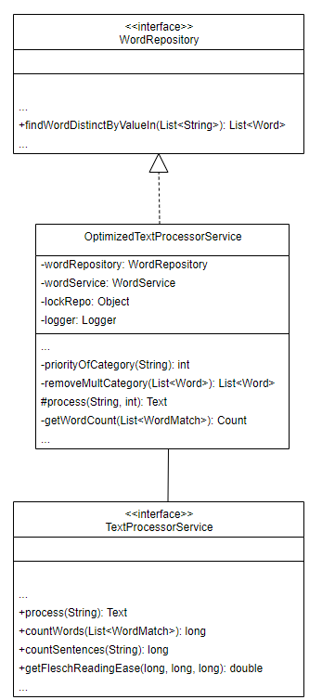

OptimizedTextProcessor_ClassDiagram

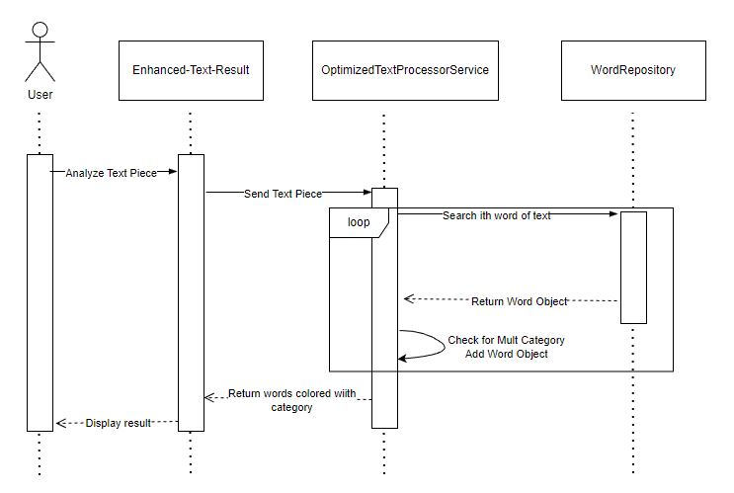

OptimizedTextProcessor_SequenceDiagram

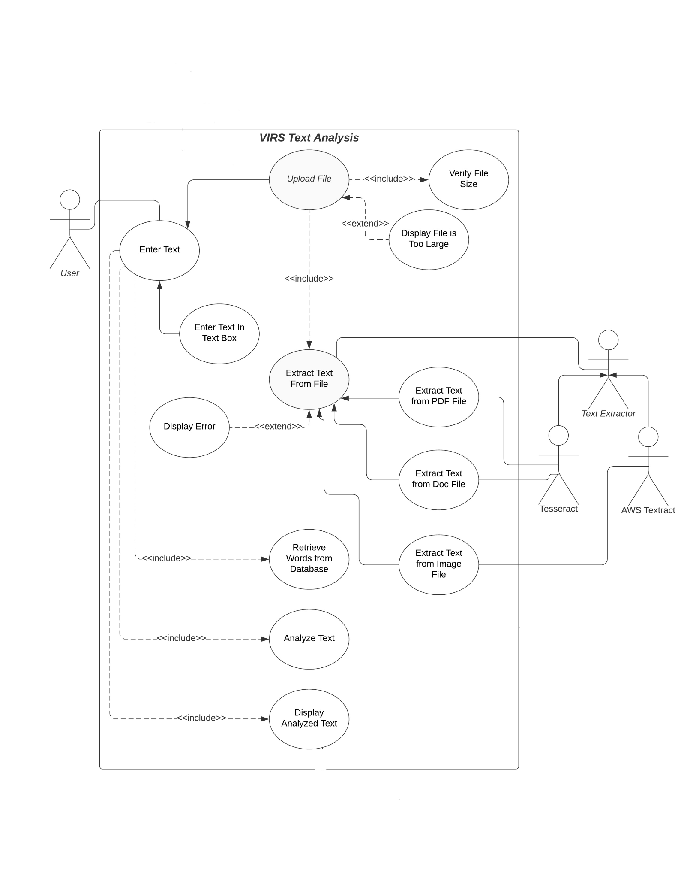

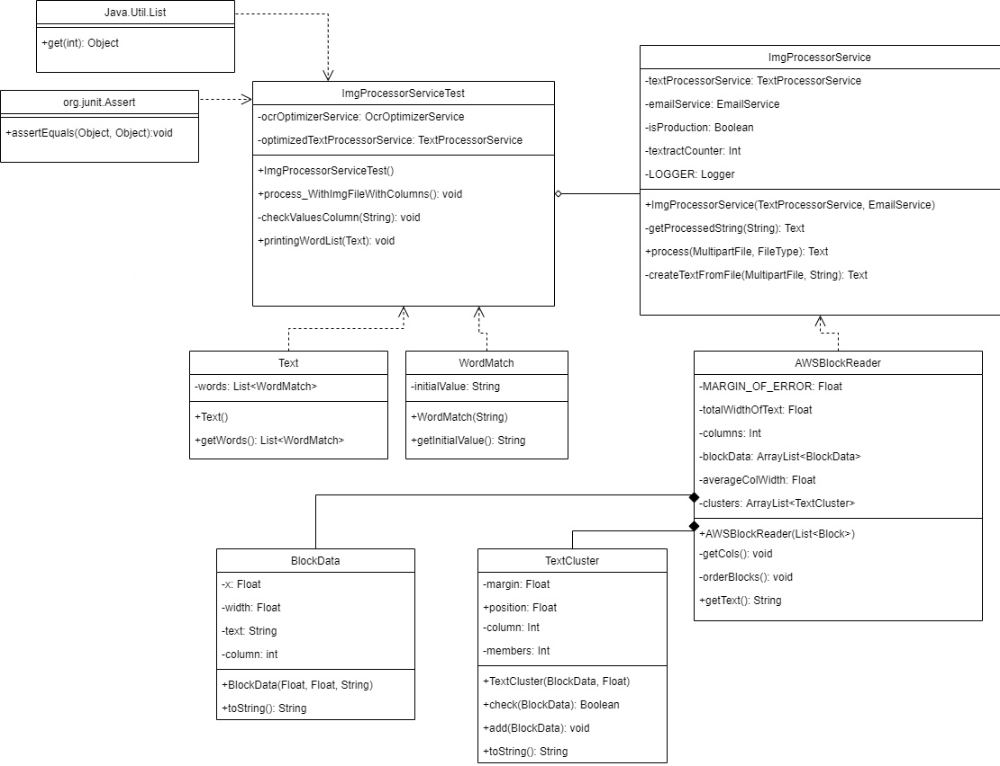

Download List Component

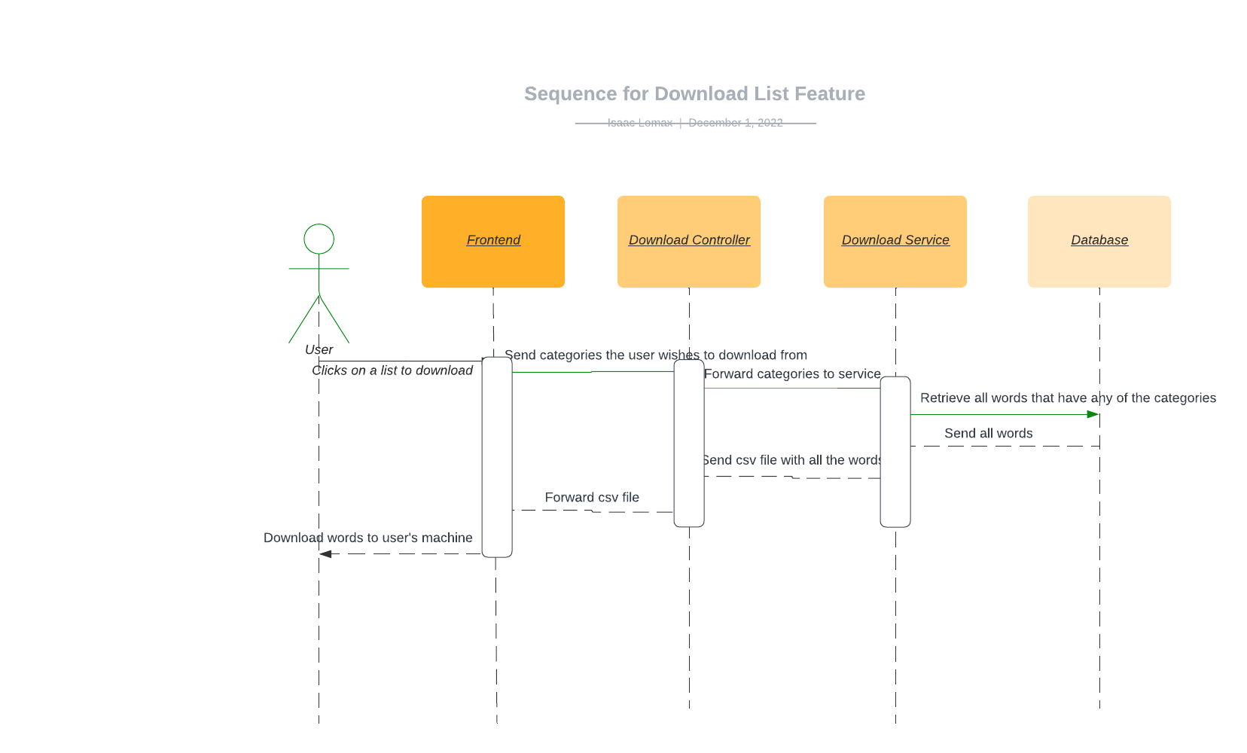

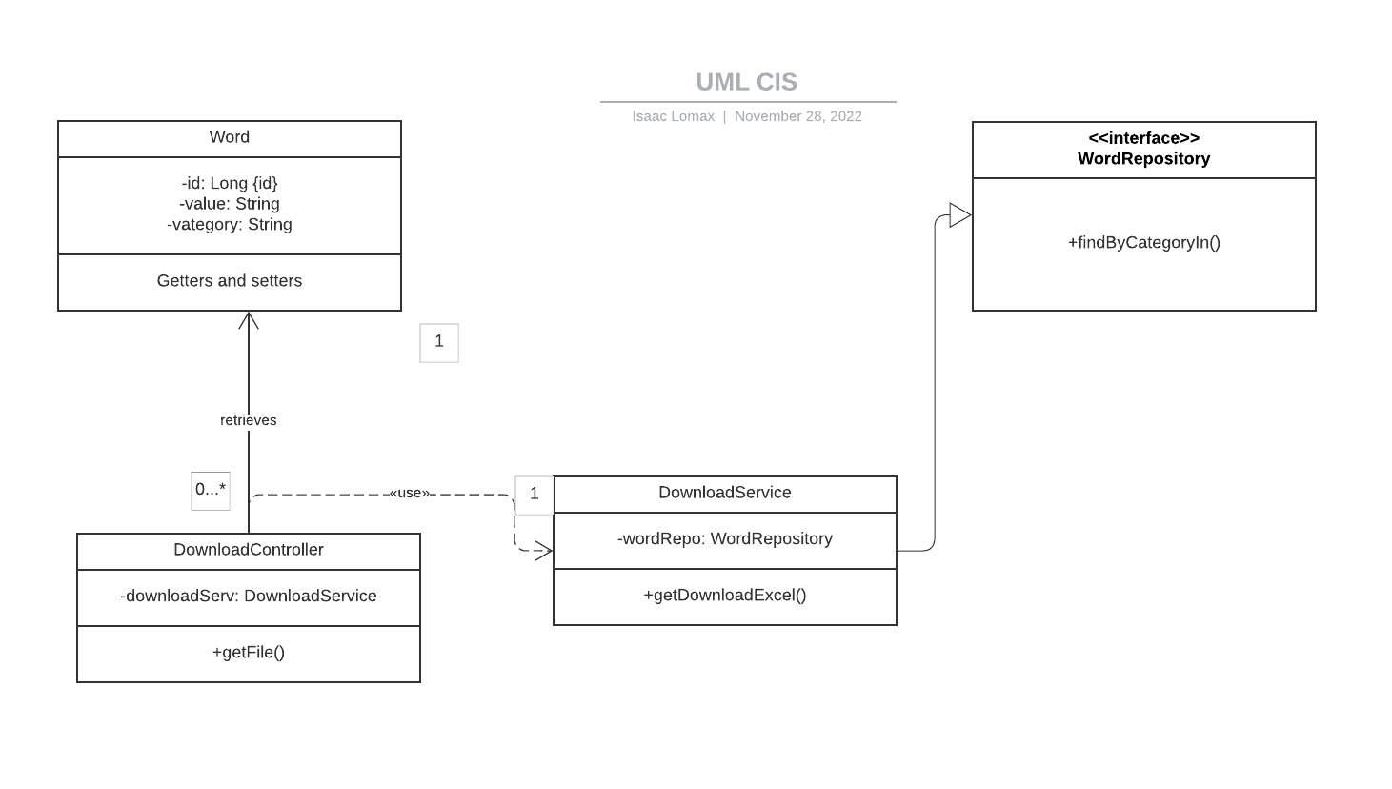

## Search Word List Component

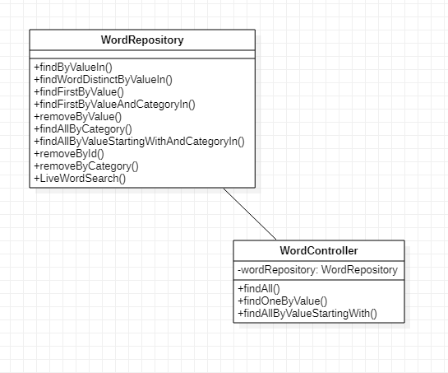

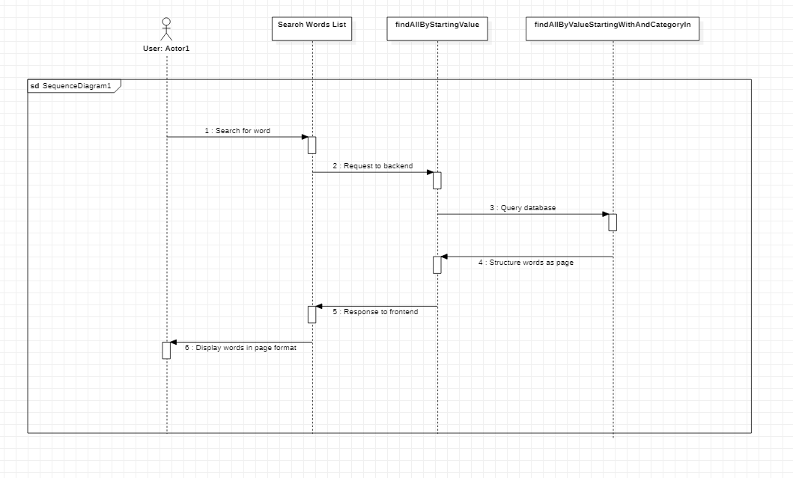

## Appendix B - User Interface Design

### Home Page

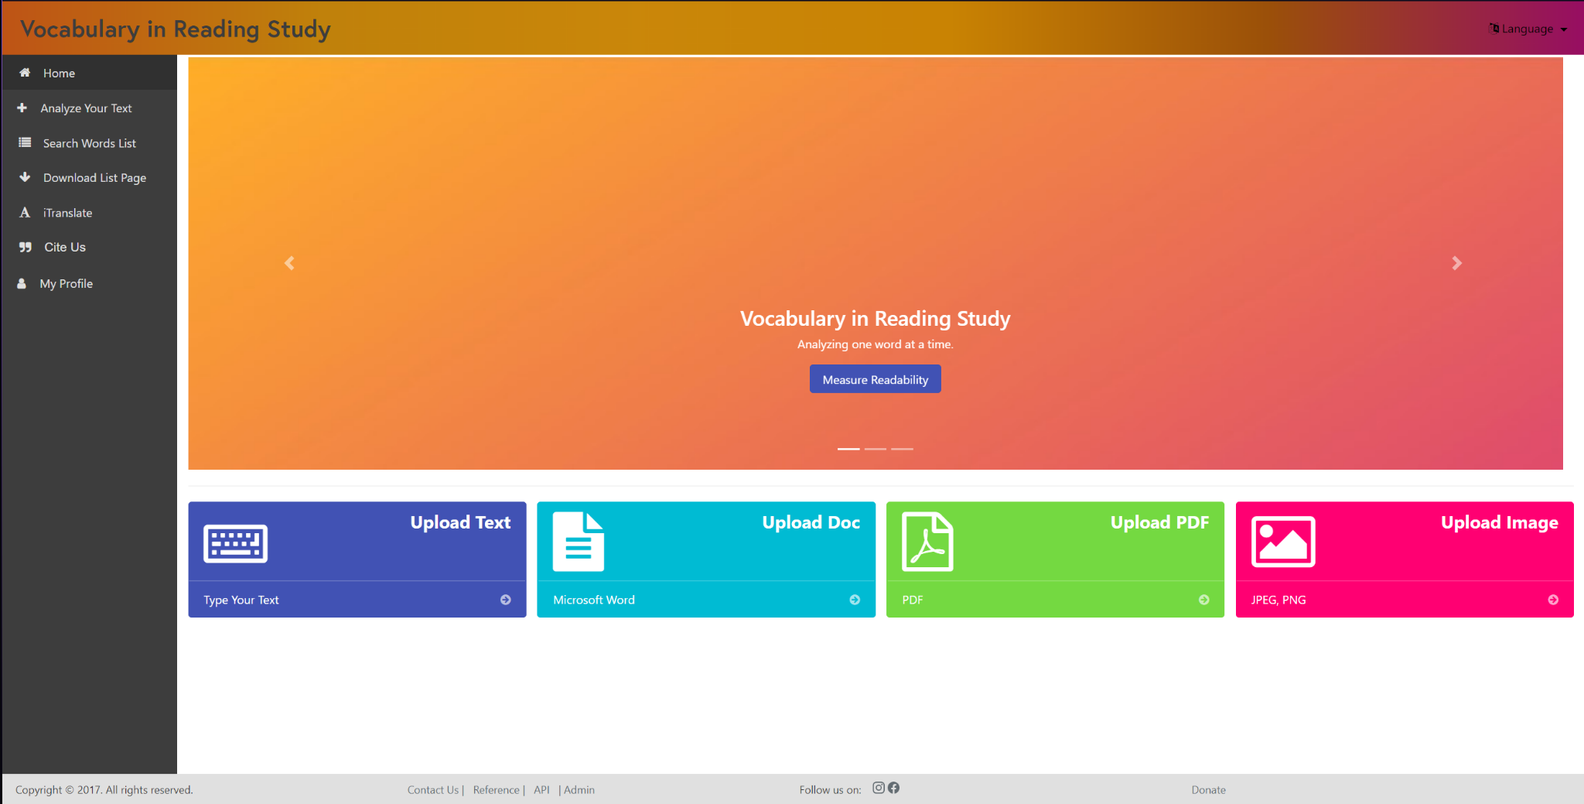

### Analyze Text

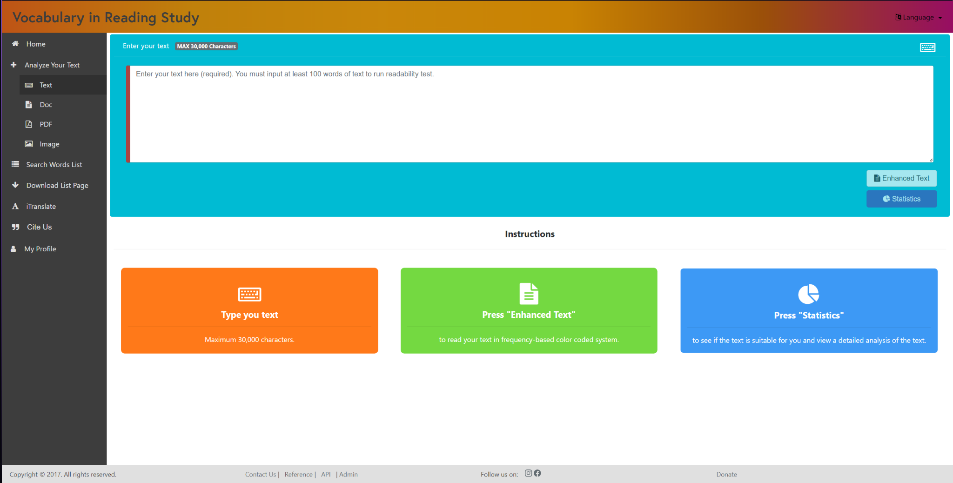

### Analyze Doc

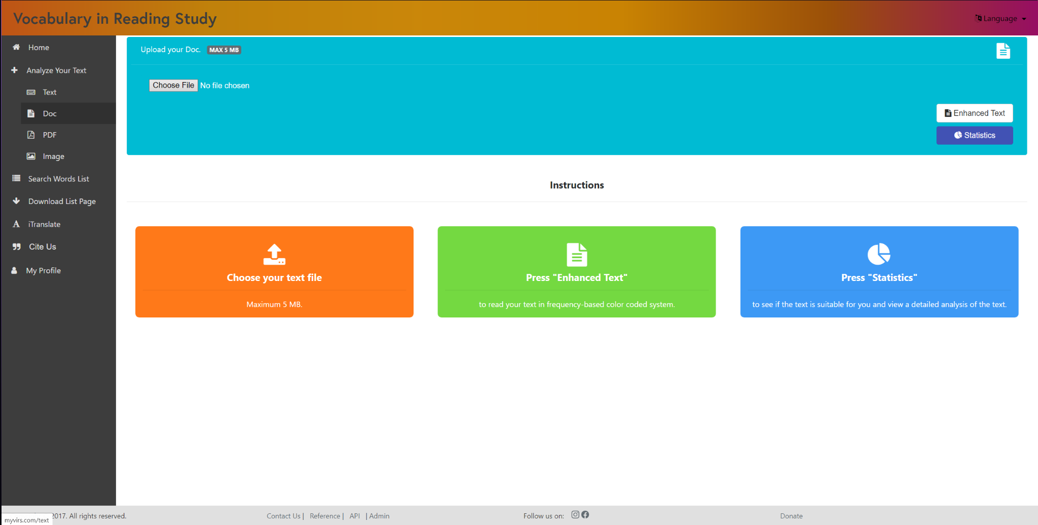

### Analyze PDF

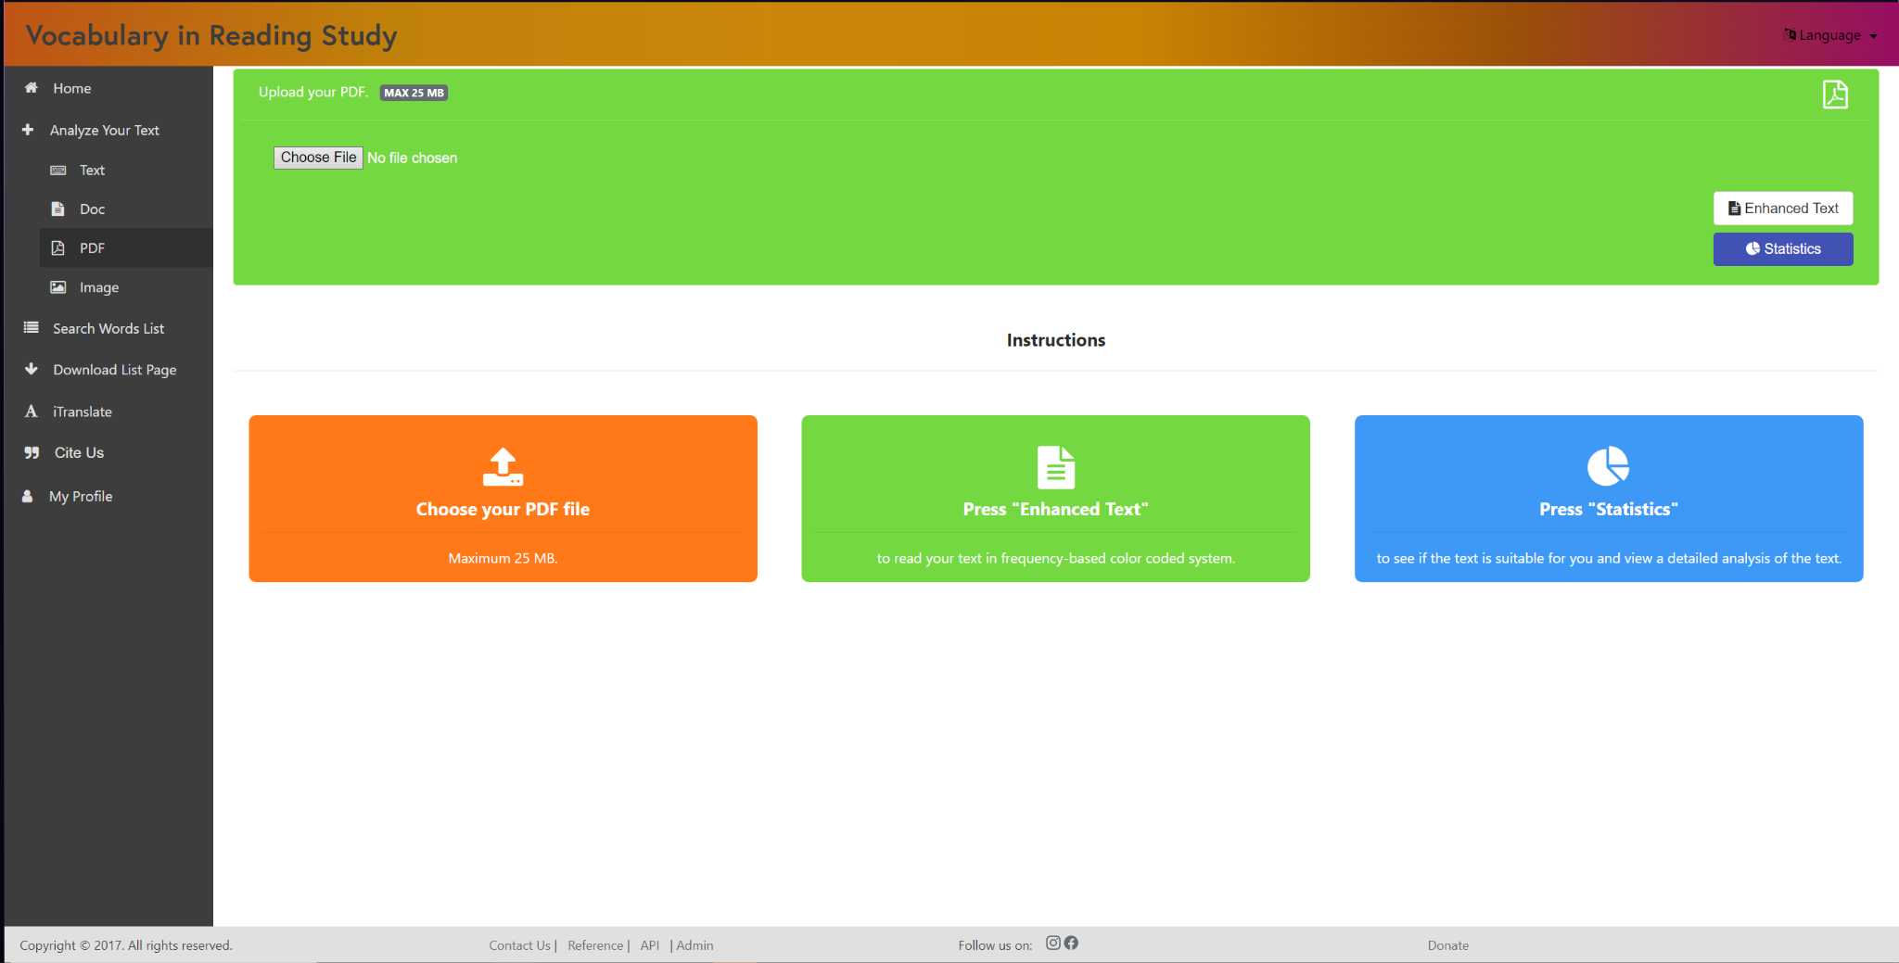

### Analyze Image

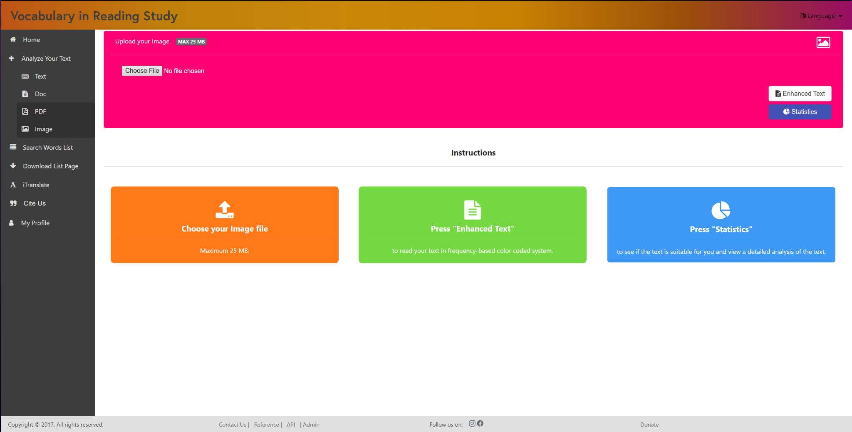

### Search Words List - Top

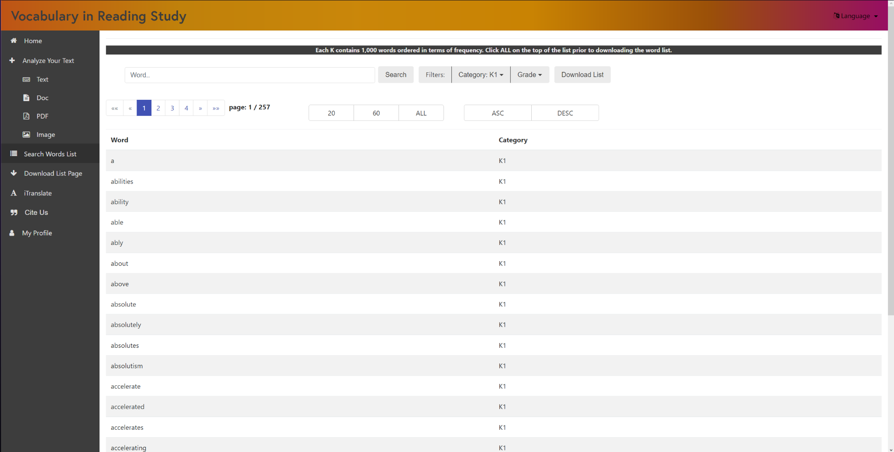

### Search Words List - Bottom

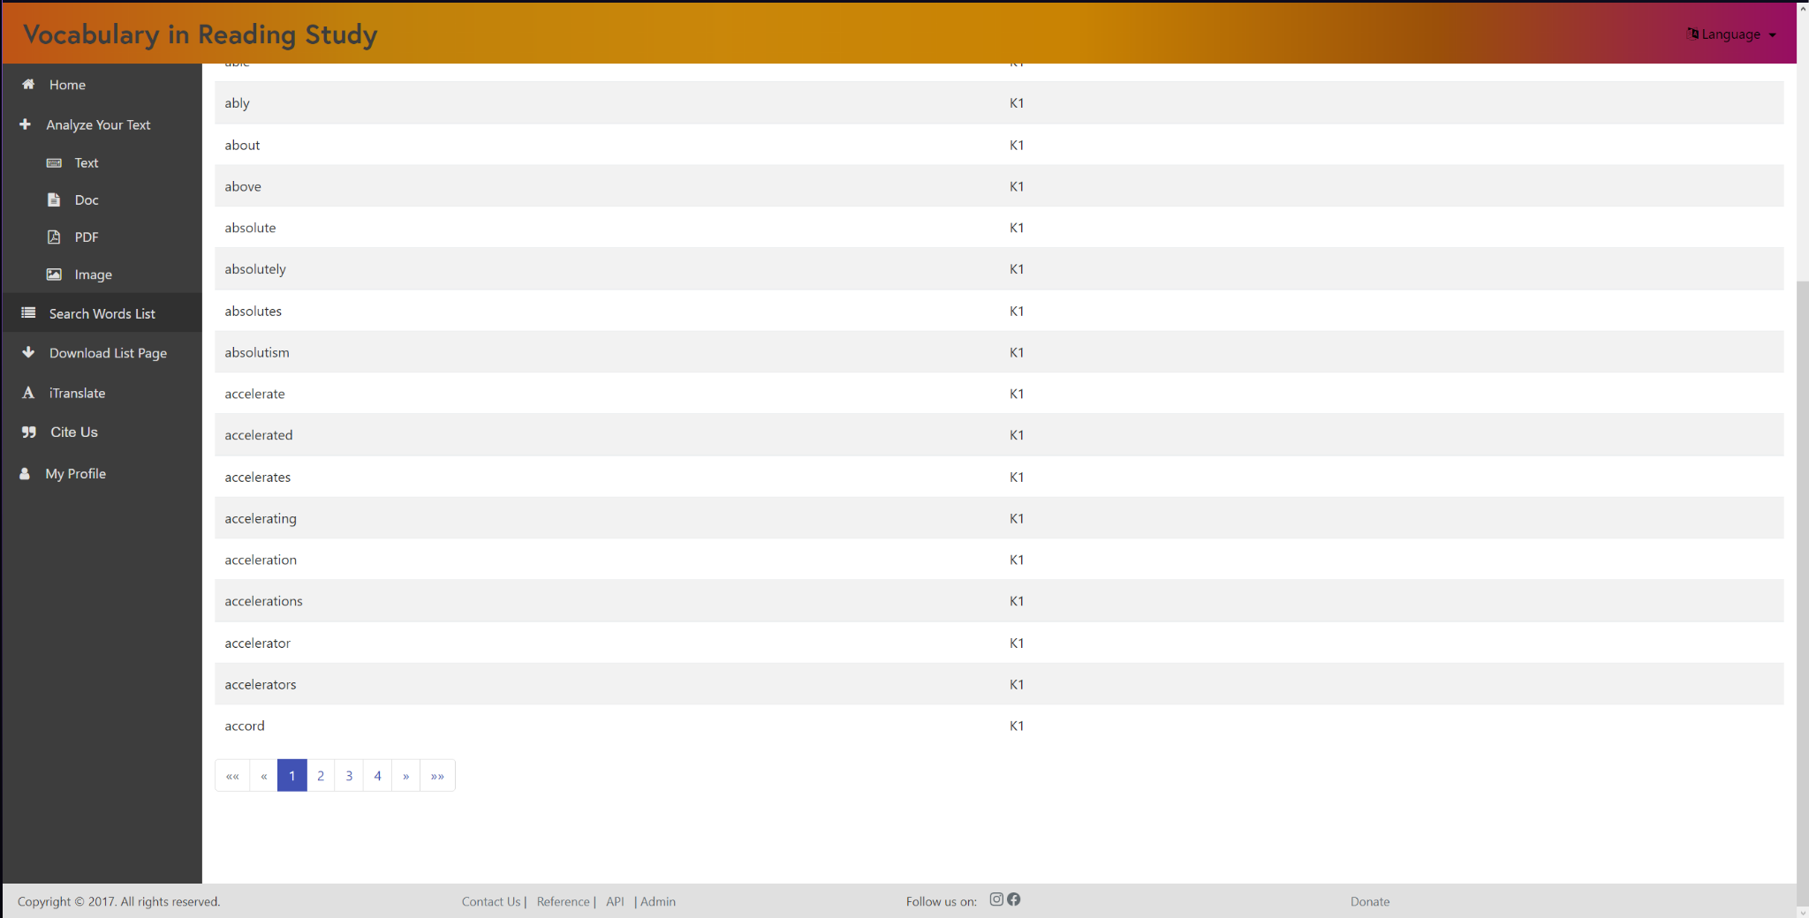

### iTranslate

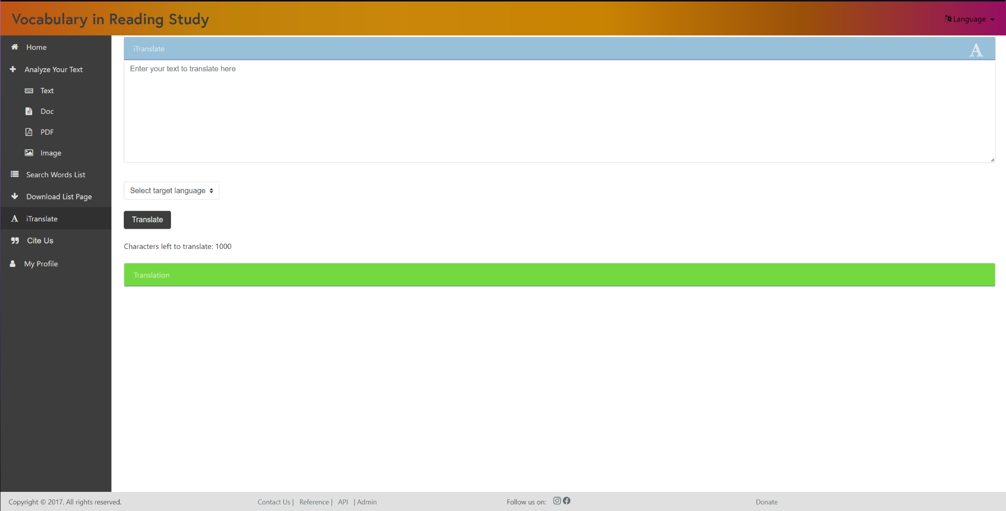

Download List Page

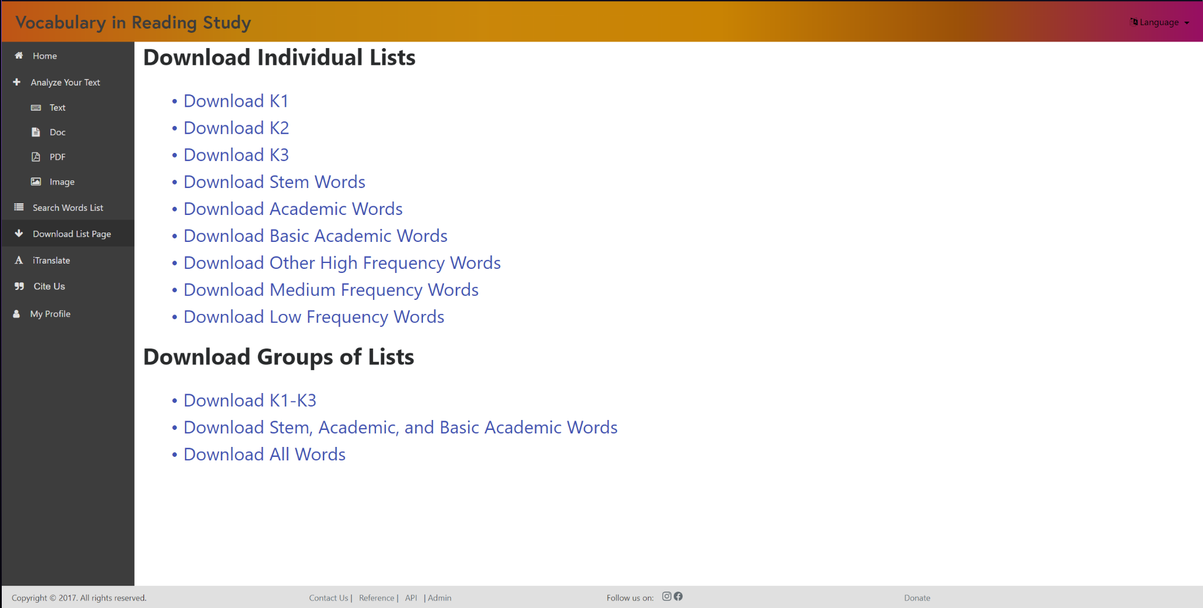

### Register

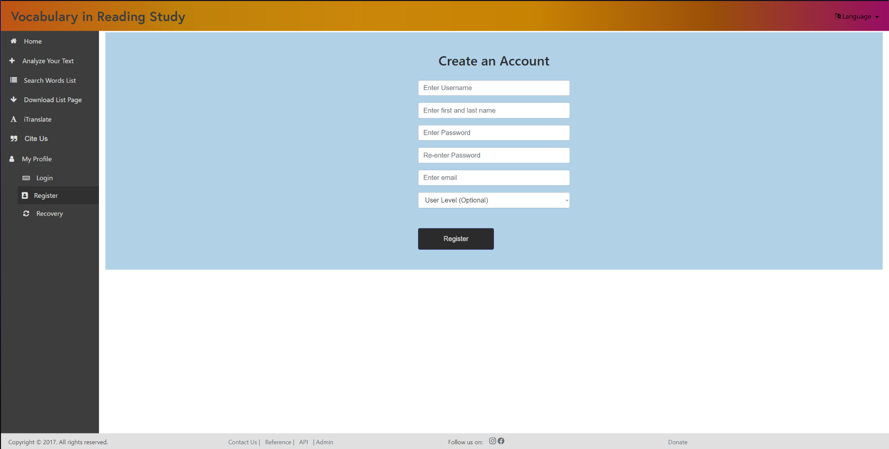

### Recovery

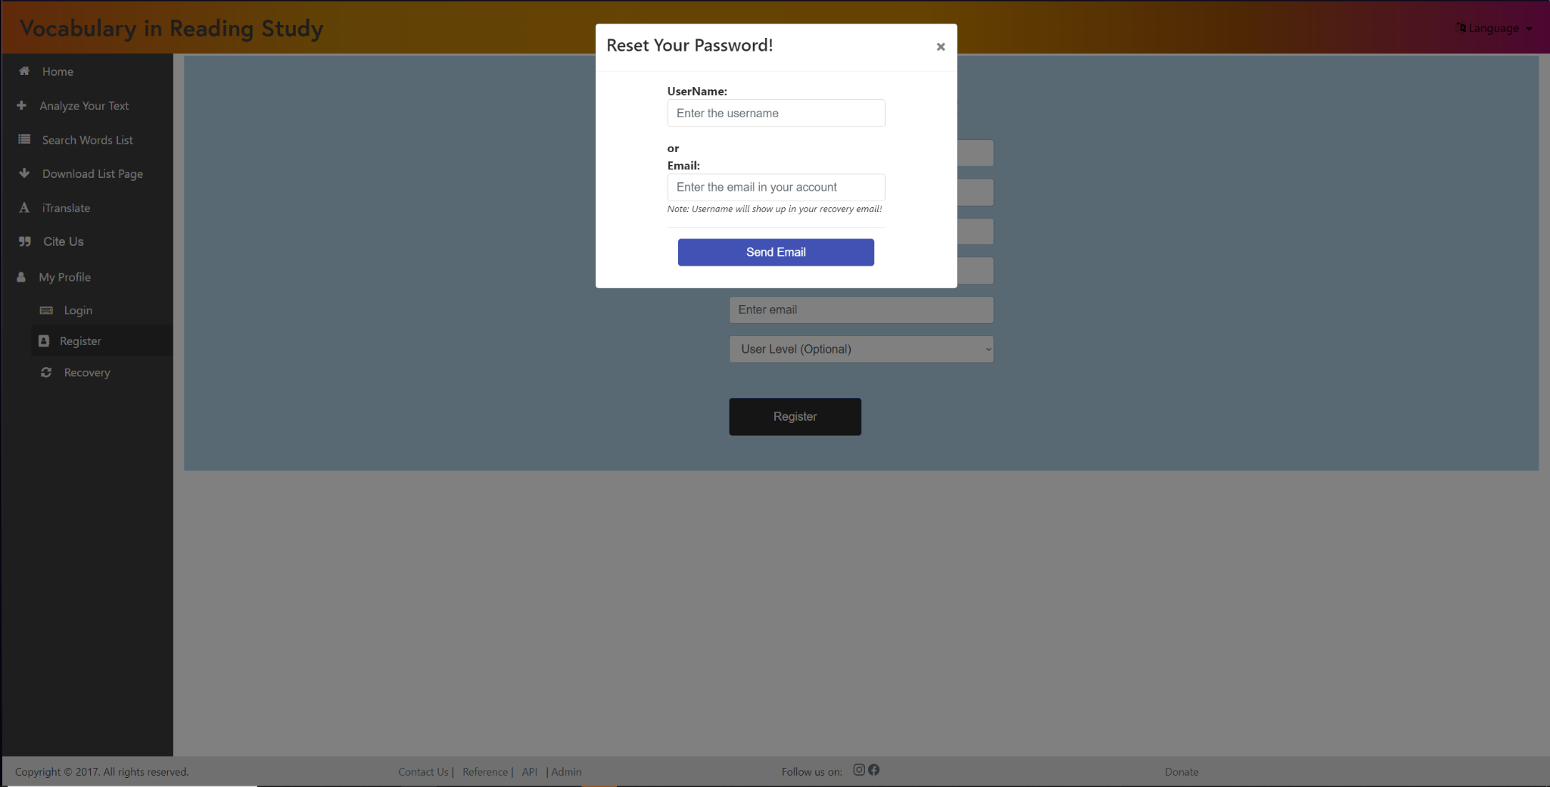

### Login

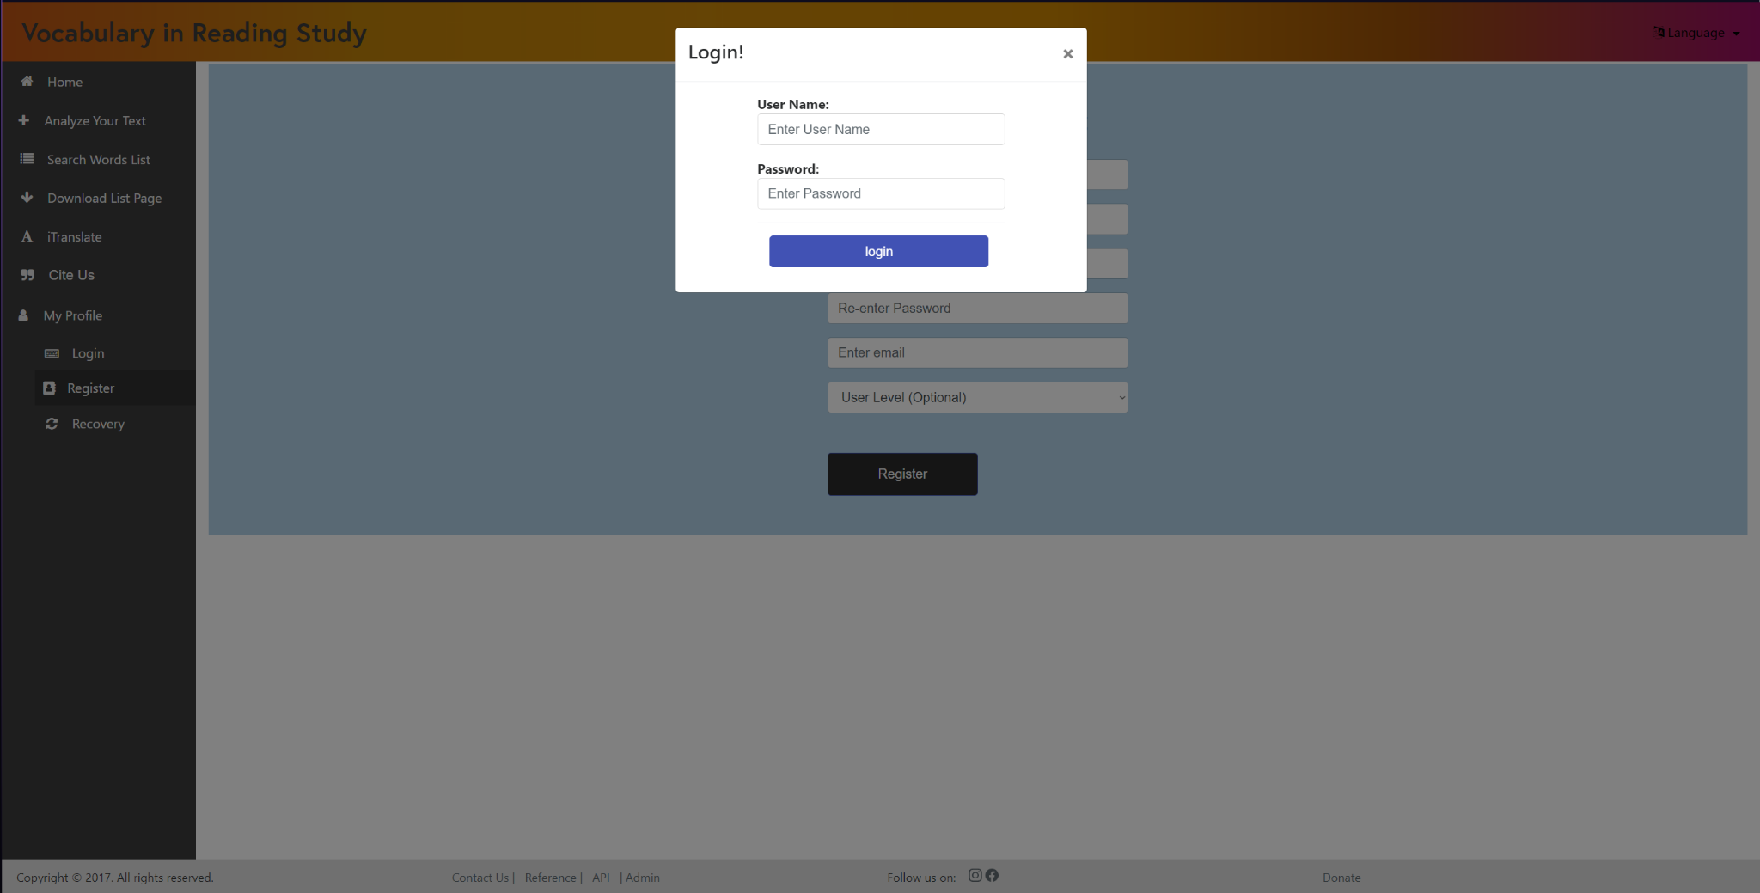

### Enhanced Text

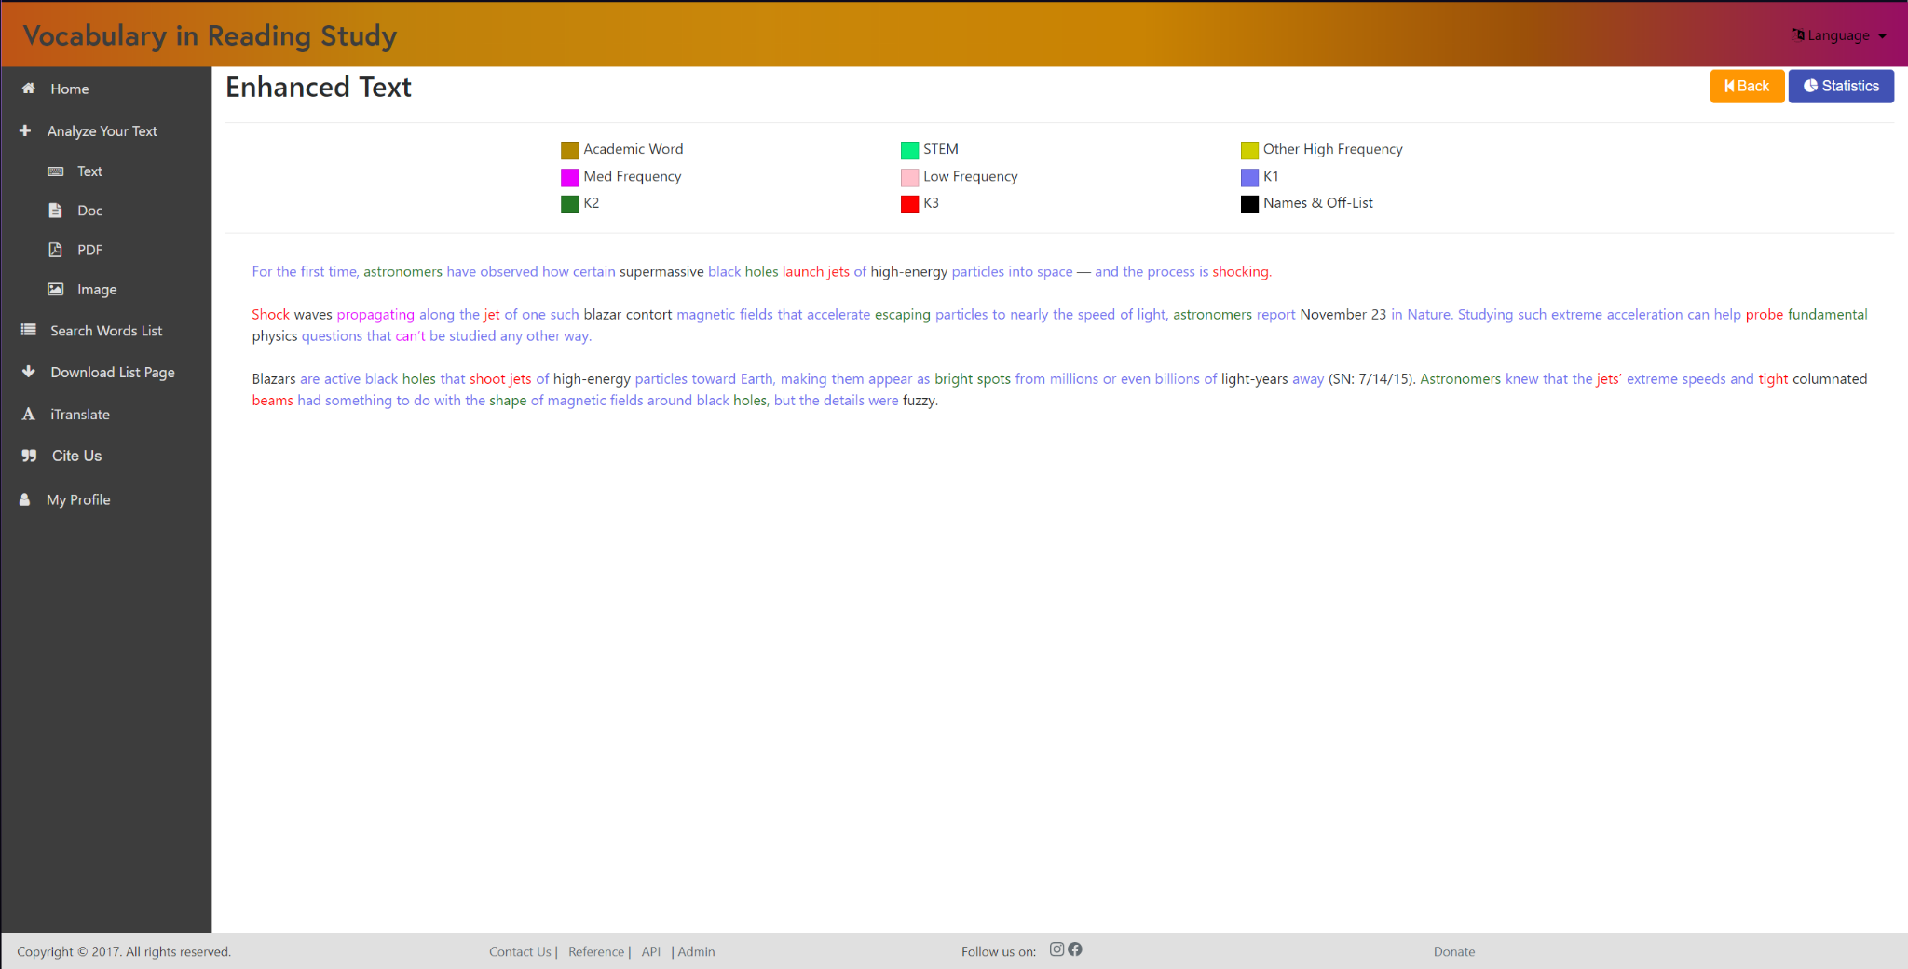

### Statistics - Top

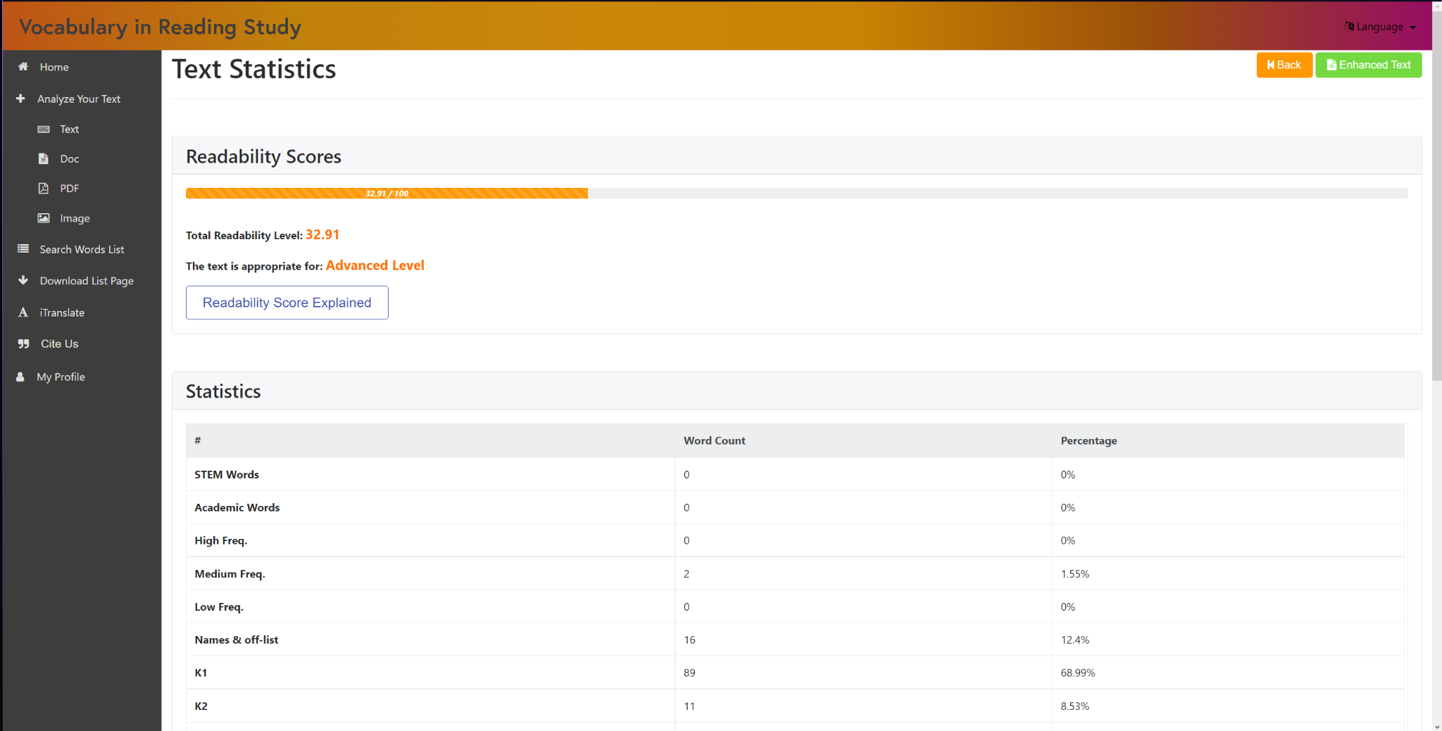

### Statistics - Bottom

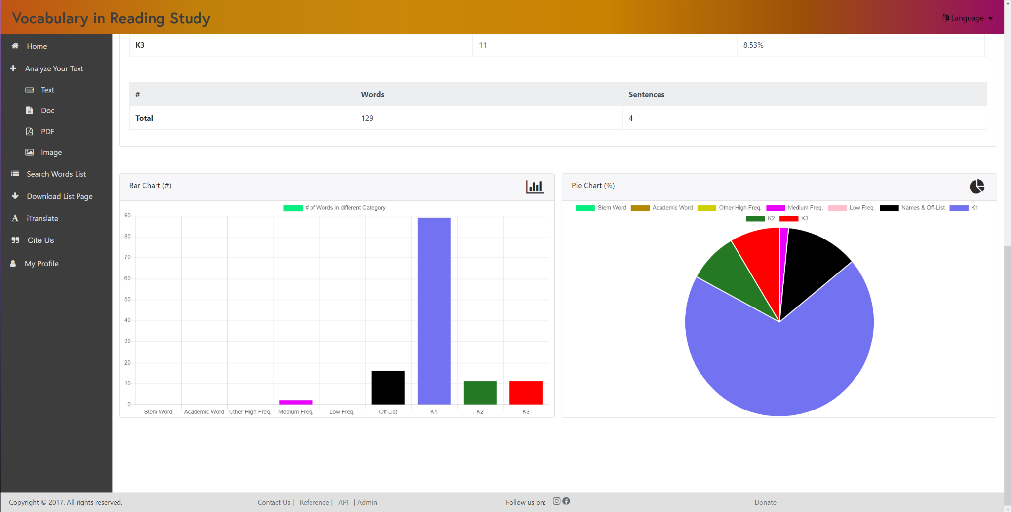

# Appendix C - Sprint Review Reports

**Sprint Review Meeting Minutes**

**Sprint 1 Review Minutes**

Attendees: **Oscar Molina, Isaac Lomax, Jose Rodriguez, Denzel Merrell, Jeffrey Quispe, Lucas Stumpf, Adrian Bustos, Denae Miller, Christopher Perez, Evers Perez, Gino Surace, Gentman Tan**

Start time: 7:00 PM

End time: 7:30 PM

After a show and tell presentation, the implementation of the following user stories were accepted by the product owners:

* User Story 1:
  + Being able to look up a word and having the app tell us which category it is in.
* User Story 2:
  + Assert that words go into their correct categories.
* User Story 3:
  + Being able to hit the return key when typing on search for a look-up.
* User Story 4:
  + Add an explanation of the categories.
* User Story 5:
  + Assure that items collected can be uploaded, as well as ask users for the type of grade the items are for.

The following ones were moved back to the product backlog to be assigned to a future sprint at a future Spring Planning meeting.

* User Story 6:
  + On the iPhone, ask users for access to their camera so they can just take a picture and then use it immediately for analysis.
* User Story 7:
  + Change the colors of the categories
* User Story 8:
  + Add grade-by-grade analysis for frequency analysis, based on 13 grades.

**Sprint 2 Review Minutes**

Attendees: **Oscar Molina, Isaac Lomax, Jose Rodriguez, Denzel Merrell, Jeffrey Quispe, Lucas Stumpf, Adrian Bustos, Denae Miller, Christopher Perez, Evers Perez, Gino Surace, Gentman Tan**

Start time: 6:00 P.M.

End time: 7:00 P.M.

* Oscar, Denzel and Isaac worked on figuring out how to run the project on our personal machines.
* Everyone worked on running the project on their personal machines.
* Everyone worked on learning about the project’s structure.

**Sprint 3 Review Minutes**

Attendees: **Oscar Molina, Isaac Lomax, Jose Rodriguez, Denzel Merrell, Jeffrey Quispe, Lucas Stumpf, Adrian Bustos, Denae Miller, Christopher Perez, Evers Perez, Gino Surace, Gentman Tan**

Start time: 6:00 P.M.

End time: 7:00 P.M.

* Made a github repo to have version control.
* Made schemas to have a clear idea of what design we want for the website.
* Made user stories more concise and decided which features/bugs were most important to focus on moving forward.

**Sprint 4 Review Minutes**

Attendees: **Oscar Molina, Isaac Lomax, Jose Rodriguez, Denzel Merrell, Jeffrey Quispe, Lucas Stumpf, Adrian Bustos, Denae Miller, Christopher Perez, Evers Perez, Gino Surace, Gentman Tan**

Start time: 6:00 P.M.

End time: 7:00 P.M.

* Fixed defaulting of words.
* Added functionality to the component that analyzes text.
* Changed certain UI components for better design.
* Started working on a new component for the website that will combine pre-existing components.

**Sprint 5 Review Minutes**

Attendees: **Oscar Molina, Isaac Lomax, Jose Rodriguez, Denzel Merrell, Jeffrey Quispe, Lucas Stumpf, Adrian Bustos, Denae Miller, Christopher Perez, Evers Perez, Gino Surace, Gentman Tan**

Start time: 6:00 P.M.

End time: 7:00 P.M.

* Added a new component that helps download all the types of lists.
* Added a functionality for searching a word in a list so that a user can type the begging of a word and all matches will show up.
* Changed certain UI components for better design.
* Started fixing some components that have missing information.

**Sprint 6 Review Minutes**

Attendees: **Oscar Molina, Isaac Lomax, Jose Rodriguez, Denzel Merrell, Jeffrey Quispe, Lucas Stumpf, Adrian Bustos, Denae Miller, Christopher Perez, Evers Perez, Gino Surace, Gentman Tan**

Start time: 6:00 P.M.

End time: 7:00 P.M.

* Added a new component that helps download all the types of lists and got it to work on the live website.
* Fixed the pagination involved with the functionality for searching a word in a list so that a user can type the beggining of a word and all matches will show up.
* Changed certain UI components for better design.
* Fixed percentages format in the statistics component.
* Removed old buttons from the mobile version of the website.